**Homework #12 Assignments**

GK Posted April 2023

**Instructions:**

Your answers should be *direct and explained*. Show your calculations, formulas, logic you follow etc. Explanations do not have to be verbose; they should be just enough for the instructor and/or TA to understand what you are doing. 80% of the grade goes to the explanations and logic you follow and 20% goes to the result. *Correct result with no explanations gets zero points*.

Please respond with your own words and own understanding. Copying the answers without understanding them, defeats the purpose of this homework -- it violates the code of ethics and the integrity of the course.

* *If you are* ***suspected*** *of copying any part of your answers either from a classmate or a web site (without a reference link), you get a zero to the entire homework.*
* *If it is* ***proven*** *that you have copied or plagiarized, you will be reported to your advisor, your sponsor, and the School; serious consequences to your academic record and/or your student status should follow.*
* *This is applicable to both the giving student and the recipient student*.

For the problems/exercises, it is expected to use a spreadsheet (Excel) and/or your own drawing tool (PowerPoint, Visio, Drawsoft, etc) or make a neat drawing by hand. ***You must embed*** these assets into your WORD file with no external references, specifically for Excel. Unless the TA or I click-and-open the object to see your calculations, you will be missing points. *If you do not know how to do so, ask your colleagues, post the question to the Discussion Homework Area, ask our TA and/or ask me.*

Please use font Arial or Calibri of 9pts or 10pts.

DO NOT REMOVE THIS PAGE FROM YOUR SUBMISSION. Also, answer the questions below:

*How long did it take you to complete this homework? _________4______ hours*

*How many hours did you work on your project this week? ____0_______ hours*

Table of Contents

1. PROGRESS, 10pts 2

2. CR, 10pts 2

3. EVAL, 25pts 2

4. ECOs, 15pts 3

5. SPOC, 25pts 3

6. BIGDIG, 15pts 4

## PROGRESS, 10pts

Today, is the 50% point of a project consisting of four activities, {A, B, C, D}. Use an appropriate tool to find which activities are on-target or not, need to be investigated further or not

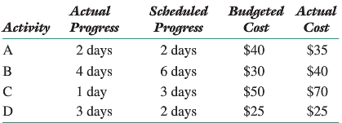

**Answer:**

A and D are on target while B and C are not and need to be further investigated.

## **CR, 10pts**

During the class we said that the denominator of CR might be either PV or EV.

1. (5pts) Prove that:

* If denominator uses PV 🡪 CR is equal to CPI
* If denominator uses EV 🡪 CR is equal to CSI

1. (10pts) Which one is better to use? Explain

*Hint: Read carefully the 11.3 section of the textbook*

**Answer:**

1. denominator uses   
   denominator uses EV
2. CSI, it focuses on schedule.

## **EVAL, 25pts**

You are doing a retrospective of a project by reviewing actual “measurements” during the past 15 weeks, consisting of:

* The Planned Budget of the n-th week
* The Expenses per Week
* The Accomplishment (Earned Value) per Week

Your record of the above is shown below:

|  |  |  |  |
| --- | --- | --- | --- |
| **Days** | **Planned** | **Weekly** | **Weekly** |
| **Budget** | **Spending** | **Accomplishments** |
| 1 | 10 | 11 | 9 |
| 2 | 20 | 10 | 10 |
| 3 | 30 | 9 | 8 |
| 4 | 40 | 10 | 7 |
| 5 | 50 | 11 | 12 |
| 6 | 60 | 10 | 11 |
| 7 | 70 | 11 | 11 |
| 8 | 80 | 9 | 13 |
| 9 | 90 | 8 | 12 |
| 10 | 100 | 9 | 9 |
| 11 | 115 | 13 | 9 |
| 12 | 120 | 12 | 11 |
| 13 | 130 | 14 | 7 |
| 14 | 140 | 11 | 8 |
| 15 | 150 | 7 | 5 |

1. (8pt) Compute the Cost Performance Index (CPI) and the Schedule Performance Index (SPI) for each week
2. (2pt) Compute the CSI
3. (5pt) Plot CPI and CSI the same graph.
4. (5pt) You plan to give a bonus to people every week that the project was doing well. For which weeks you will give a bonus?
5. Consider week #11. If you have done your calculations right, EV=AC. That is your expenses are equal to your progress. Would you give the bonus or not?

**Answer:**



4. Weeks that is highlighted in green in spreadsheet

5. No, because SPI is less than 100% which means the progress is behind of plan.

## **ECOs, 15pts**

In Class #12, we discussed the Change Order forms and showed the following

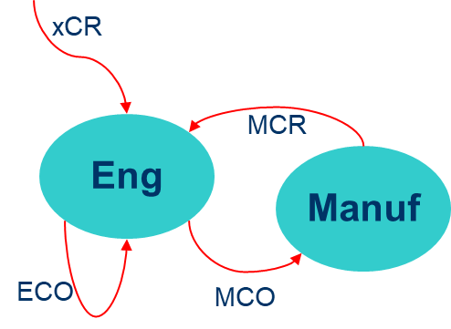

1. (3pt) Explain all the acronyms
2. (7pt) Explain the flow(s) between Engineering and Manufacturing
3. (5pt) Why an ECO is needed?

**Answer:**

1. MCR: Manufacturing Change Request  
   ECR: Engineering Change Request  
   PCR: Process Change Request  
   ECO: Engineering Change Order

MCO: Manufacturing Change Order

1. Engineering team initiates manufacturing process changing order, and manufacturing team feedback manufacturing change request according to its capabilities.
2. To document and approve changes to a product's design or specifications, ensuring compliance with quality and regulatory standards.

## SPOC, 25pts

Project SPOC included the following tasks.

|  |  |  |  |  |
| --- | --- | --- | --- | --- |
| **TASK** | **Predecessors** | **Duration (weeks)** | **Budget** | **Pct of Completion** |
|  |  |  |  |  |
| A | - | 6 | $ 900 | 100% |
| B | - | 6 | $ 1,200 | 100% |
| C | A | 6 | $ 1,200 | 100% |
| D | A | 12 | $ 1,800 | 100% |
| E | B, C | 14 | $ 1,400 | 100% |
| F | B, C, D | 10 | $ 1,500 | 40% |
| G | D, E | 16 | $ 800 | 0% |

Before the end of the project, at week 24 the project expenses were $7,500.

1. (5pt) Create a PERT Chart of this project

* Mark on the chart the Budget planned per task

1. (5pt) Create a Gantt Chart of this project

* Include the budget/cost per task

1. (10pt) Compute the following for the 24th week
   * + PV
     + EV
     + AC
2. (5pt) Is the project progressing well or there is a problem? Use a quantitative metrics and explain your answer.

**Answer:**

* 1. 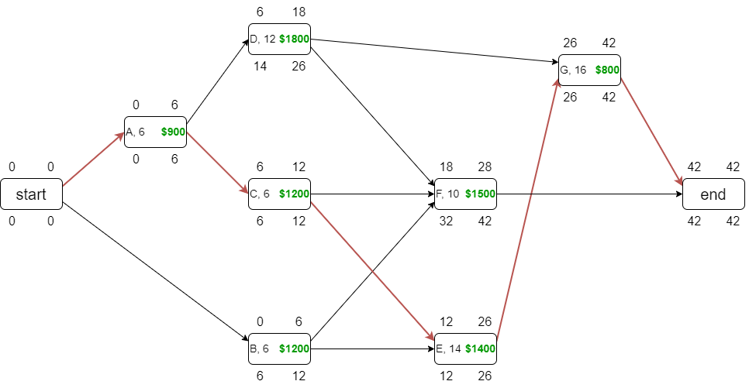
  2. Timeline

     Description automatically generated with medium confidence

|  |  |  |  |
| --- | --- | --- | --- |
|  | | cost | |
| budget | actual |
| Work | scheduled | PV=$5029 |  |
| performed | EV=$7100 | AC=$7500 |

progressing well but cost the cost currently outweighs the earned value

## BIGDIG, 15pts

Read from the textbook the Major Scope Creep in Boston’s “Big Dig”

1. What elements of the project do you think escalated about 400 percent?
2. What do you expect the outcome would have been if the city had been required to pay half the costs?

**Answer:**

1. cost
2. - more serious local deliberation of the project  
   - more careful consideration of the project's scope and a better understanding of its costs and benefits  
   - increase accountability